**Test case:**

**Functional testing:**

Functional testing of a website is testing that validates the functionalities of the website against the functional requirements. The aim of functional testing is to test each function of the website, by providing correct input, verify the output of the website. It ensures whether they are working as per requirement.

|  |  |  |  |  |  |
| --- | --- | --- | --- | --- | --- |
| Test no. | Test title | Testing process | Expected result | Actual result | Action taken |
| 1 | Functional testing | Enquiry from website | There is an enquire form in the website. User will be able to query for anything about the University. It will be stored in the database and the admin will give the answer my mail. | Form fields have no validation check. My information have not stored in the database. | None |
| 2 | Functional testing | Contact form | There is a contact form in the website. User will be able to contact with the University. It will be stored in the database and the admin will give the answer my mail. | Form fields have no validation check. My information have not stored in the database. | None |
| 3 | Functional testing | Events calendar | User will be able to set event calendar and event category. | Working but there is no event to edit date. | None |

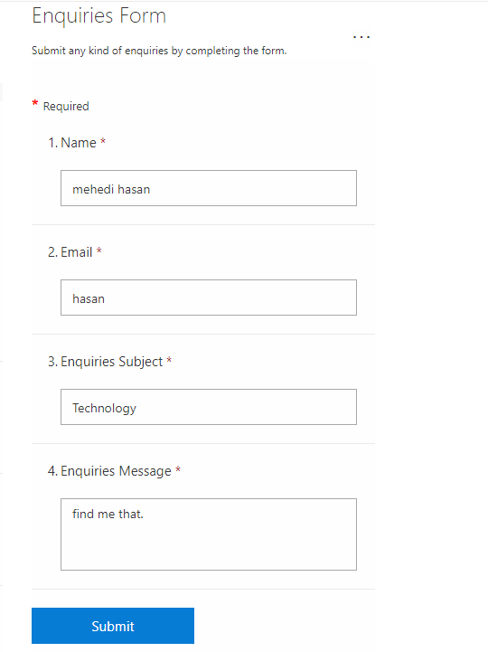

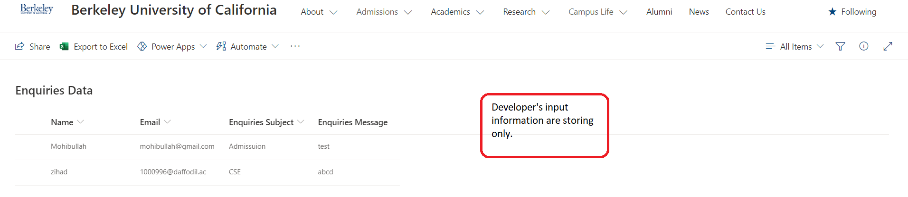

Figure: Functionality enquiry.

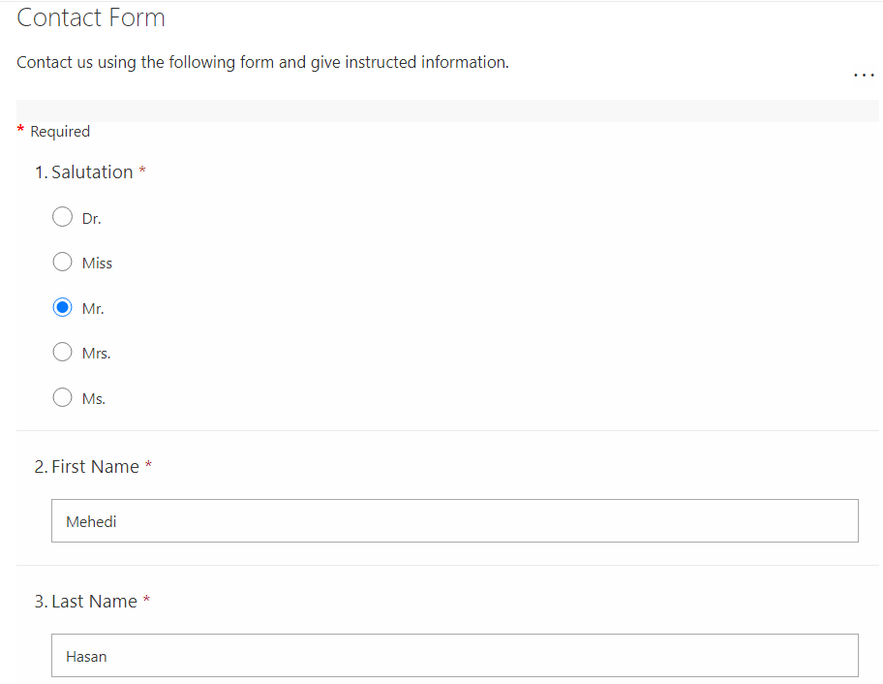

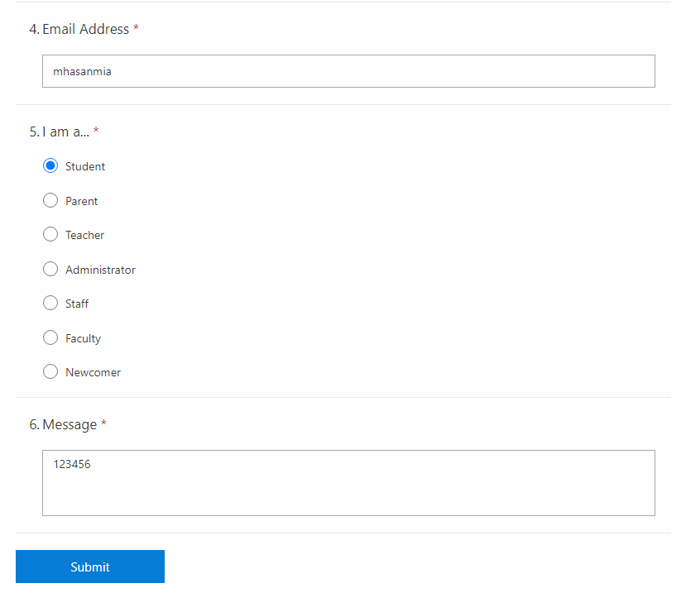

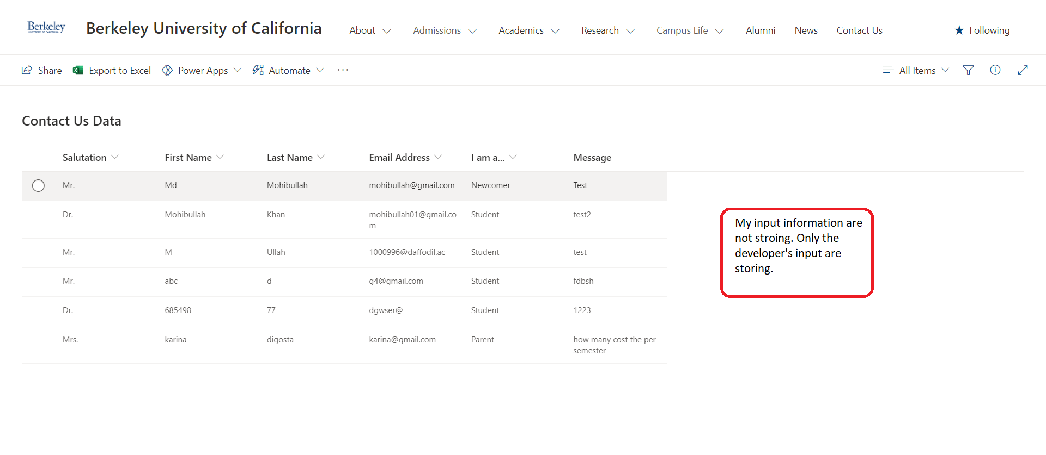

Figure: Functionality of contact form

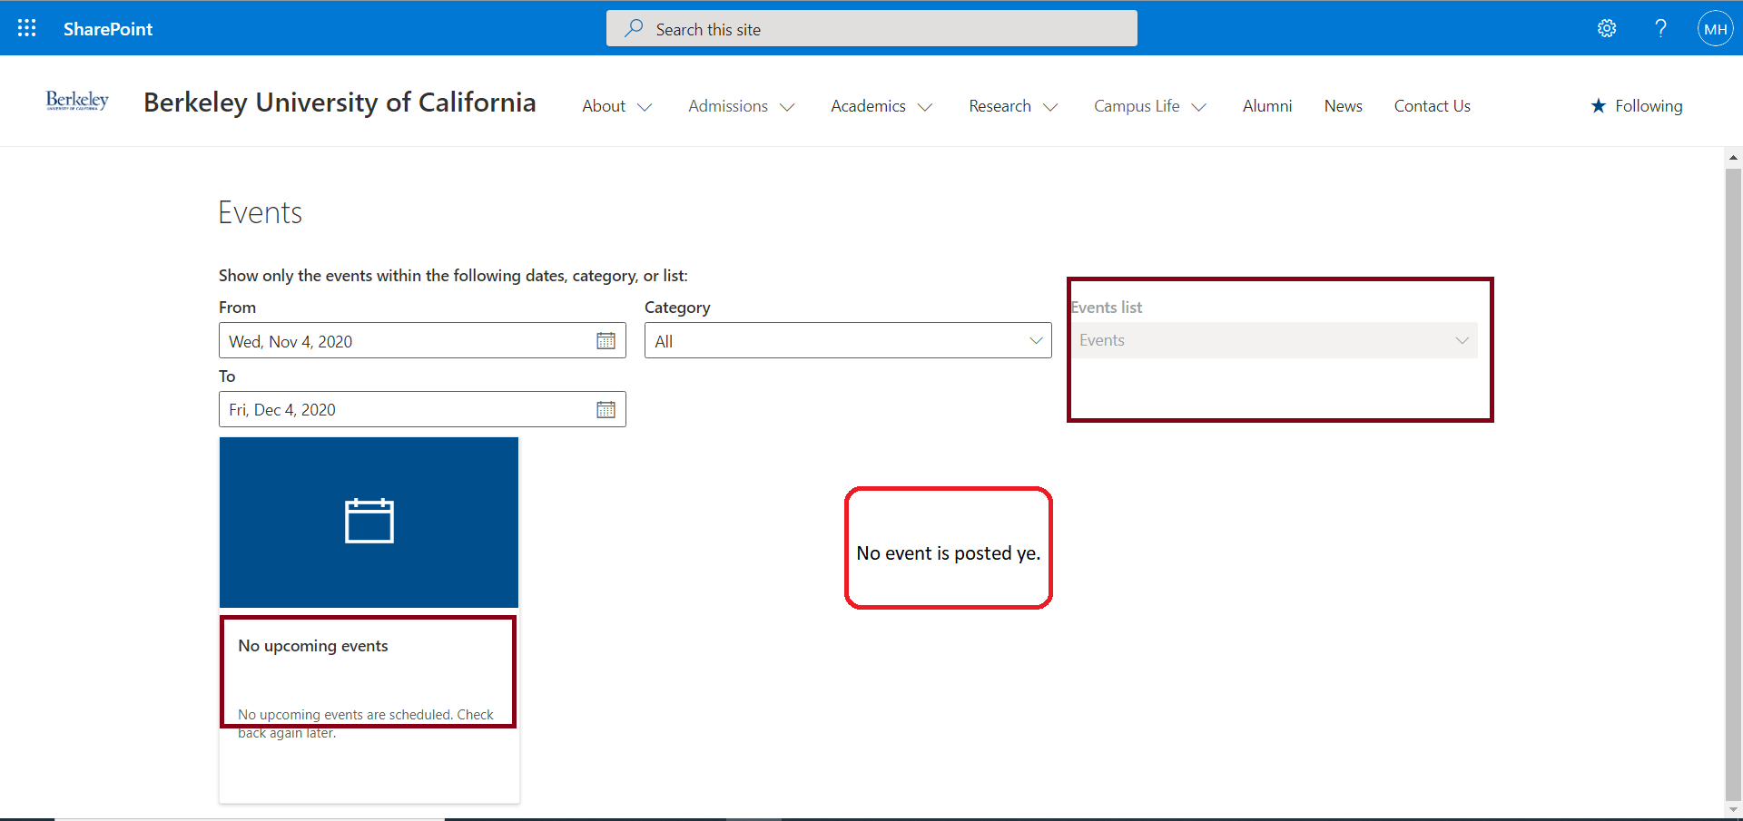

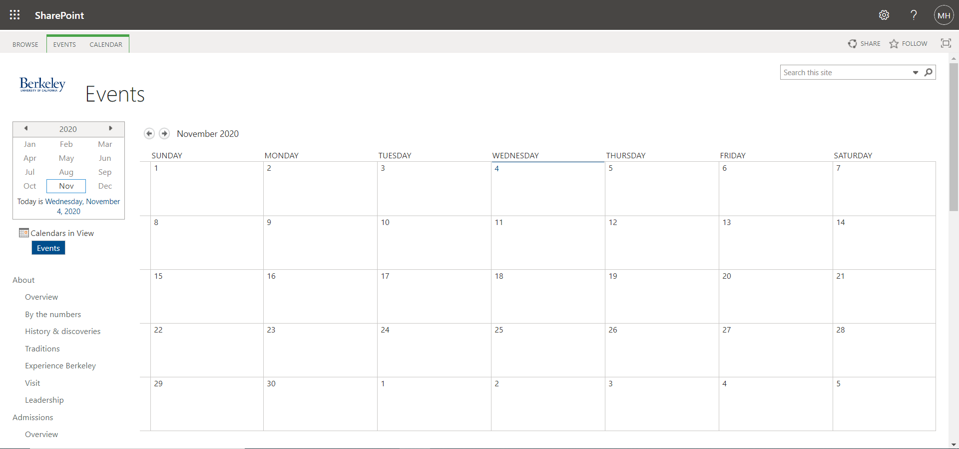

Figure: Functionality of calendar.

**Unit testing:**

Unit testing means the testing of each section of any web application. Unit testing confirms that each section or unit of an application meets the expected design and behaves as intended. The testing is actually an individual function or procedure. Considering contact us form as a whole module I will test all the units of the module:

|  |  |  |  |  |  |
| --- | --- | --- | --- | --- | --- |
| Test no. | Test title | Testing process | Expected result | Actual result | Action taken |
| 1 | Unit testing | Click on “ any link” | The entire link will work. Mail link will open a mail window. | Mail link open a mail window for mailing, other link works but the link page is not developed. | None |
| 2 | Unit testing | Click on “submit” button | Inputting all data of contact form, it will store information in the contact form database. | Only the developer’s data are stored in the database. | None |

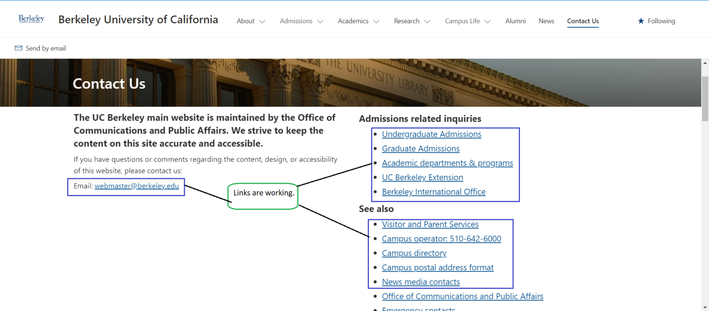

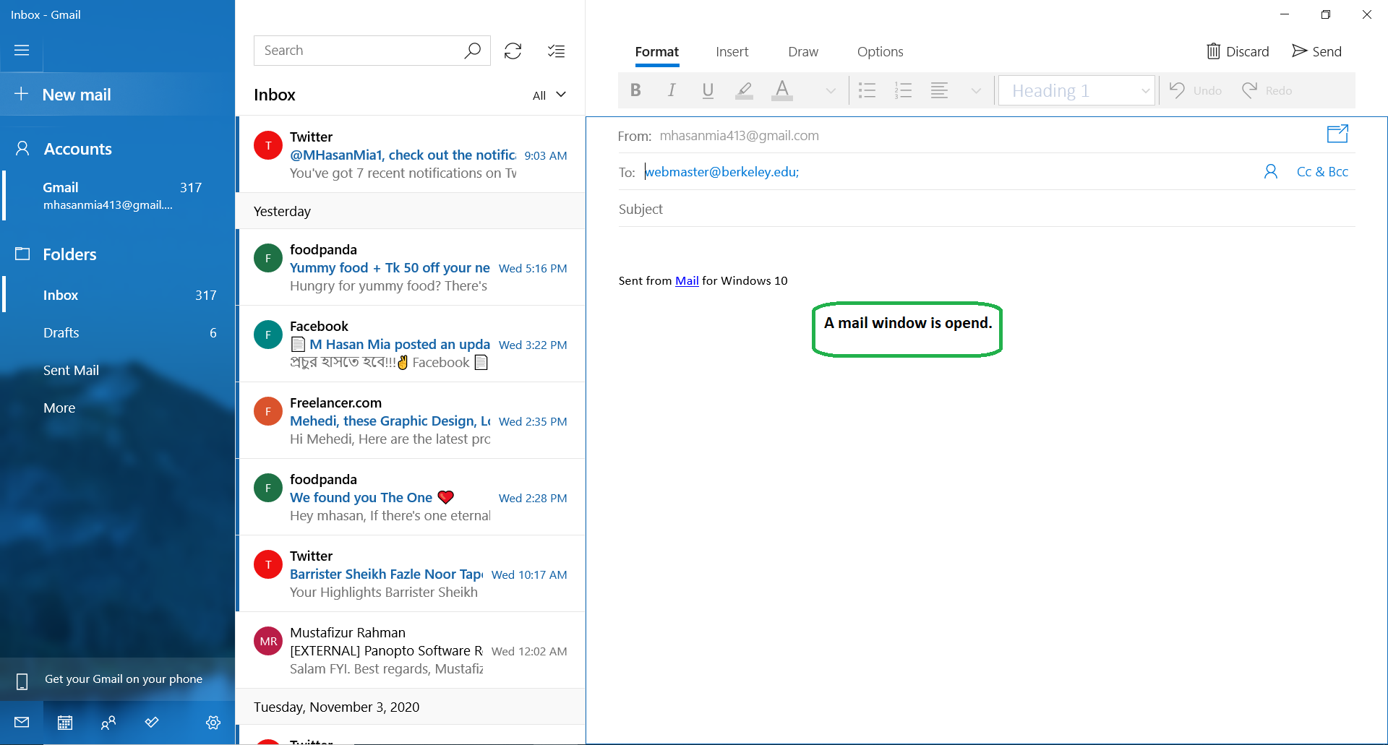

Figure: Unit testing for link.





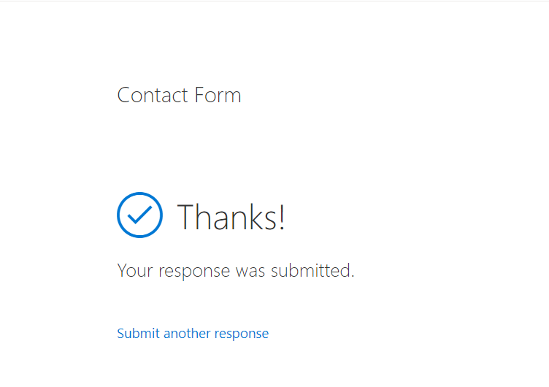



Figure: Unit testing for submit button.

**Integration testing:**

It is a kind of software testing to test each components of any website they are working as needed. The testing integrates all the testing components together and makes an output result of the testing.

|  |  |  |  |  |  |
| --- | --- | --- | --- | --- | --- |
| Test no. | Test title | Testing process | Expected result | Actual result | Action taken |
| 1 | Integration testing | Click on “Schools and colleges” | Our developed website has the feature under the Academics menu. Clicking on “Schools and colleges” it will appear a page and show the school and college sections. | It has worked perfectly. All the links are working. | None |
| 2 | Integration testing | Click on “News” | Clicking on “News” it will appear a page where all the news of the website is posted. | It has worked perfectly. All the news is posted orderly and working perfectly. | None |
| 3 | Integration testing | Click on “Contact Us” | It will appear a page where contact form and enquires form will be showed. | Contact form and enquires form have been showed successfully. | None |
| 4 | Integration testing | Click on “Research” | It will appear a page and it will show all the research overviews are stored. | It has worked successfully. | None |

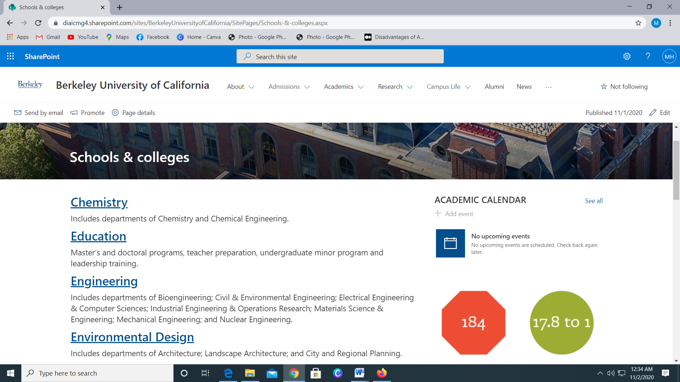

Figure: Integration testing on “Schools and colleges”.

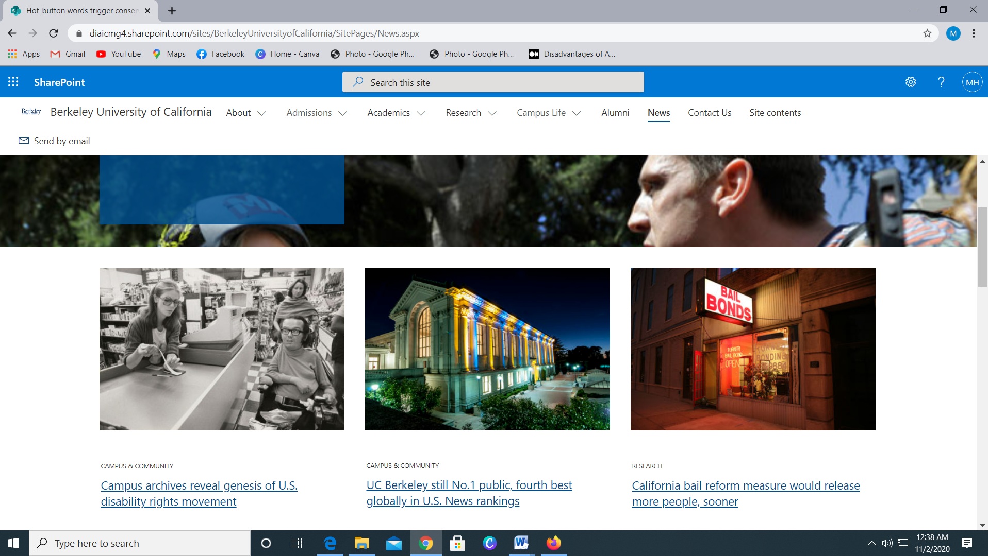

Figure: Integration testing on “News”.

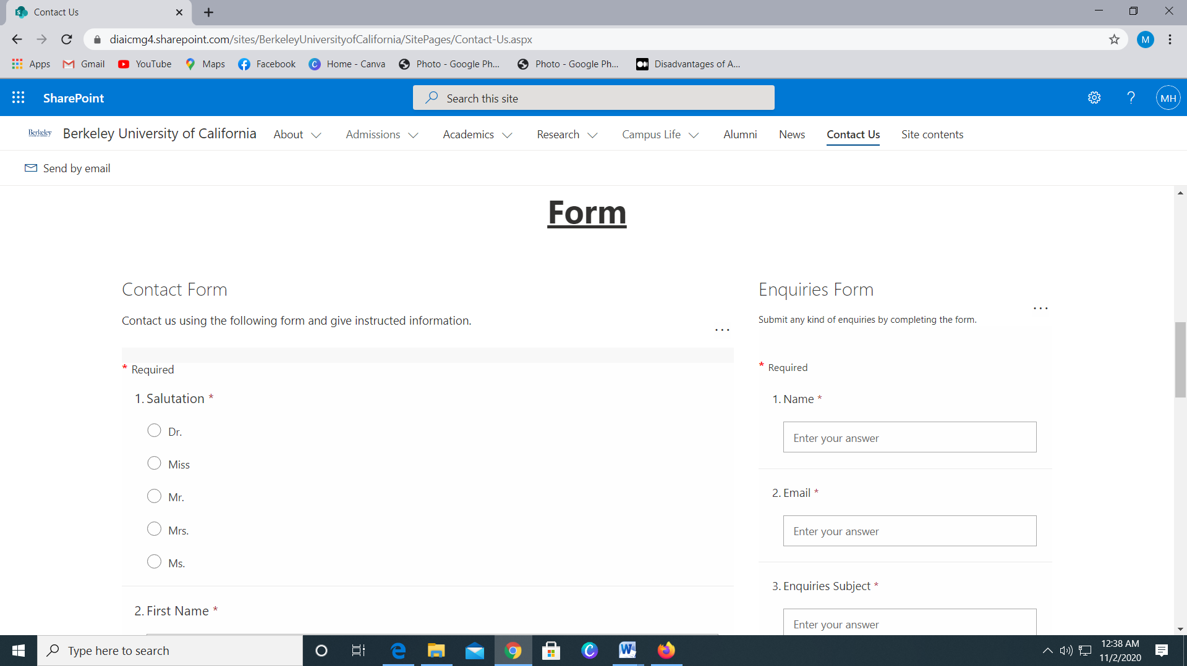

Figure: Integration testing on “Contact Us”.

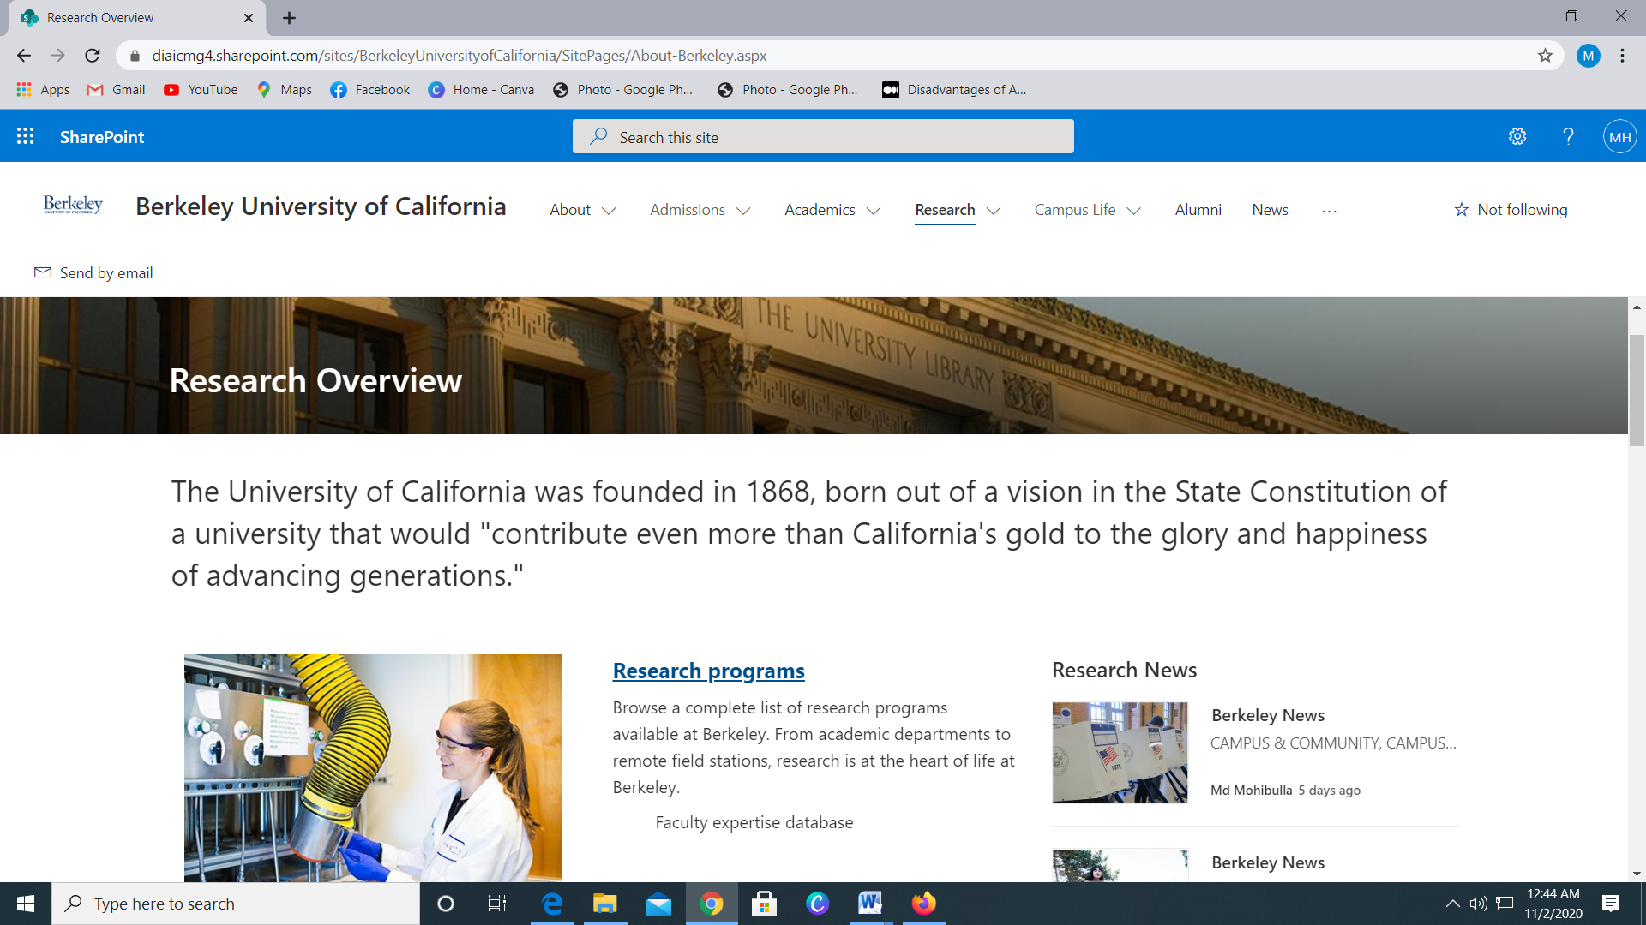

Figure: Integration testing on “Research”.

**Usability testing:**

In the case of a website the usability testing is a technique that used to evaluate the website by testing it on users of the website. It is a practice of testing how easy a design can be used by a group of representative users. Before the release of the website usability test confirm that the functions of the website are easily useable to the users.

|  |  |  |  |  |  |
| --- | --- | --- | --- | --- | --- |
| Test no. | Test title | Testing process | Expected result | Actual result | Action taken |
| 1 | Usability testing | Click on “menu bar” | The website menu will be designed nicely and will show drop down list while placing the cursor on each menu item. | While placing the cursor on any item a drop down list opens every time. | None |
| 2 | Usability testing | Click on “videos” | There are some videos in the website such as research video, news video. All the videos will run and work perfectly. | Clicking on the videos, they are plying. | None |
| 3 | Usability testing | Click on “links” | All the links of the website will work. Though every link page is not developed, News feature is developed successfully. | Links are working. | None |

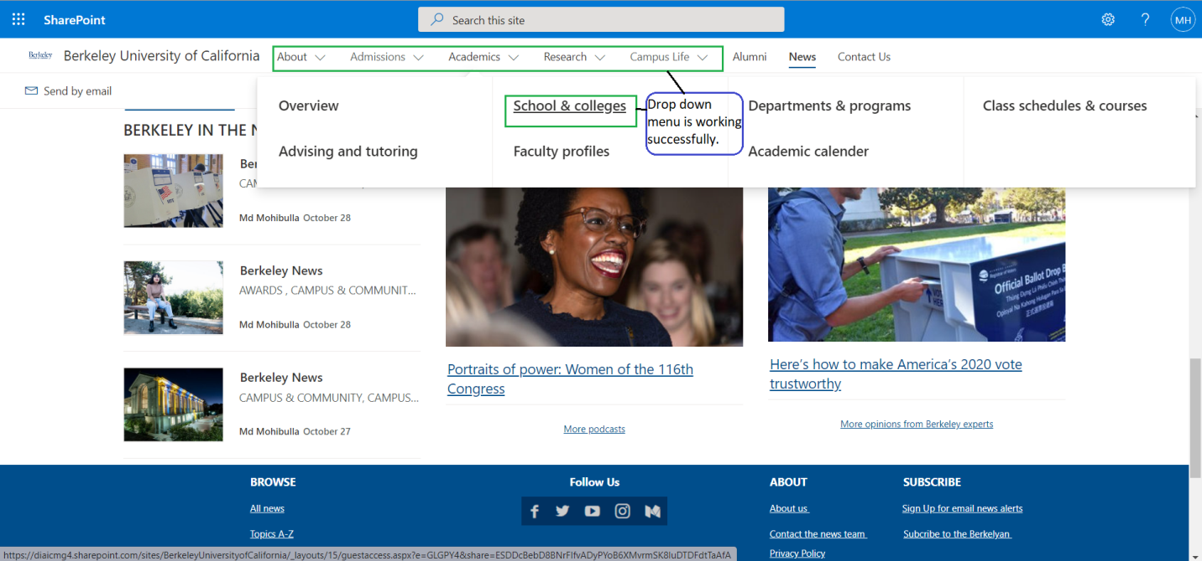

Figure: Usability of drop down menu.

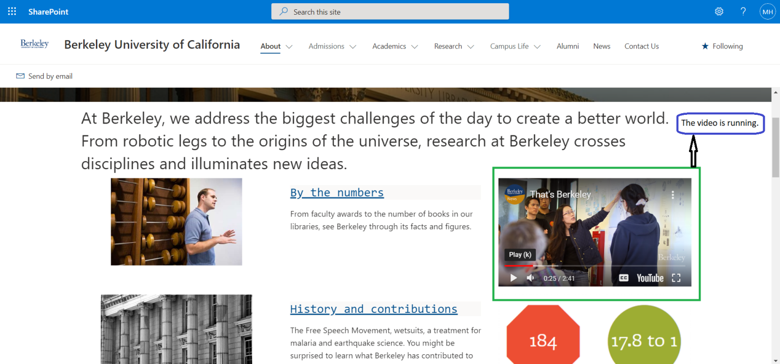

Figure: Usability of drop video.

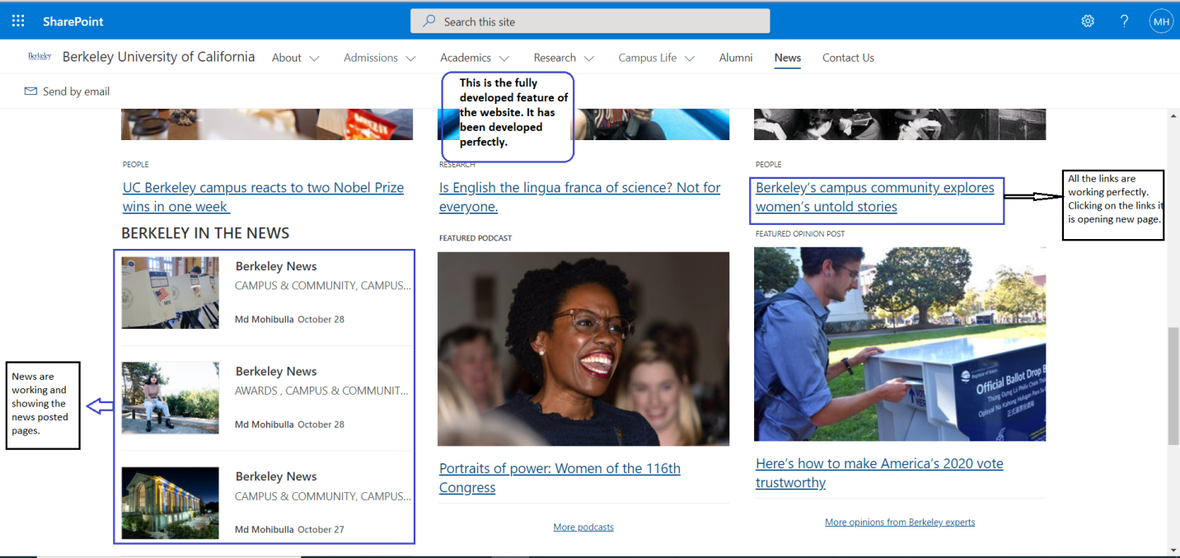

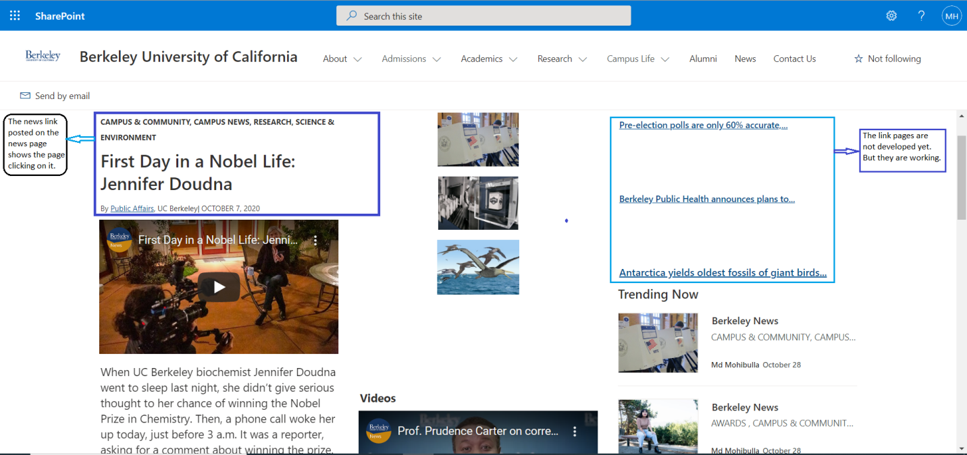

Figure: Usability of links.

**Security testing:**

In a test case of a website, security testing is very important part of the test case. Security testing involves identifying the risks, threats, and vulnerabilities in a web application. The testing purpose is to prevent any cyber-criminal to access and launch malicious attacks. Security testing makes the website secure from all the sections of using the website.

As we developed the website using free CMS SharePoint, developer can excess to any part. I will show just a demo of security testing.

|  |  |  |  |  |  |
| --- | --- | --- | --- | --- | --- |
| Test no. | Test title | Testing process | Expected result | Actual result | Action taken |
| 1 | Security testing | Database excess. | As the website is developed without coding, the CMS security is very poor. Nobody should not excess to the database. | Any group member can excess the database easily. | None |
| 2 | Security testing | Vulnerability | As we used a free CMS for developing the website, there could be malicious code. | Not found. | None |

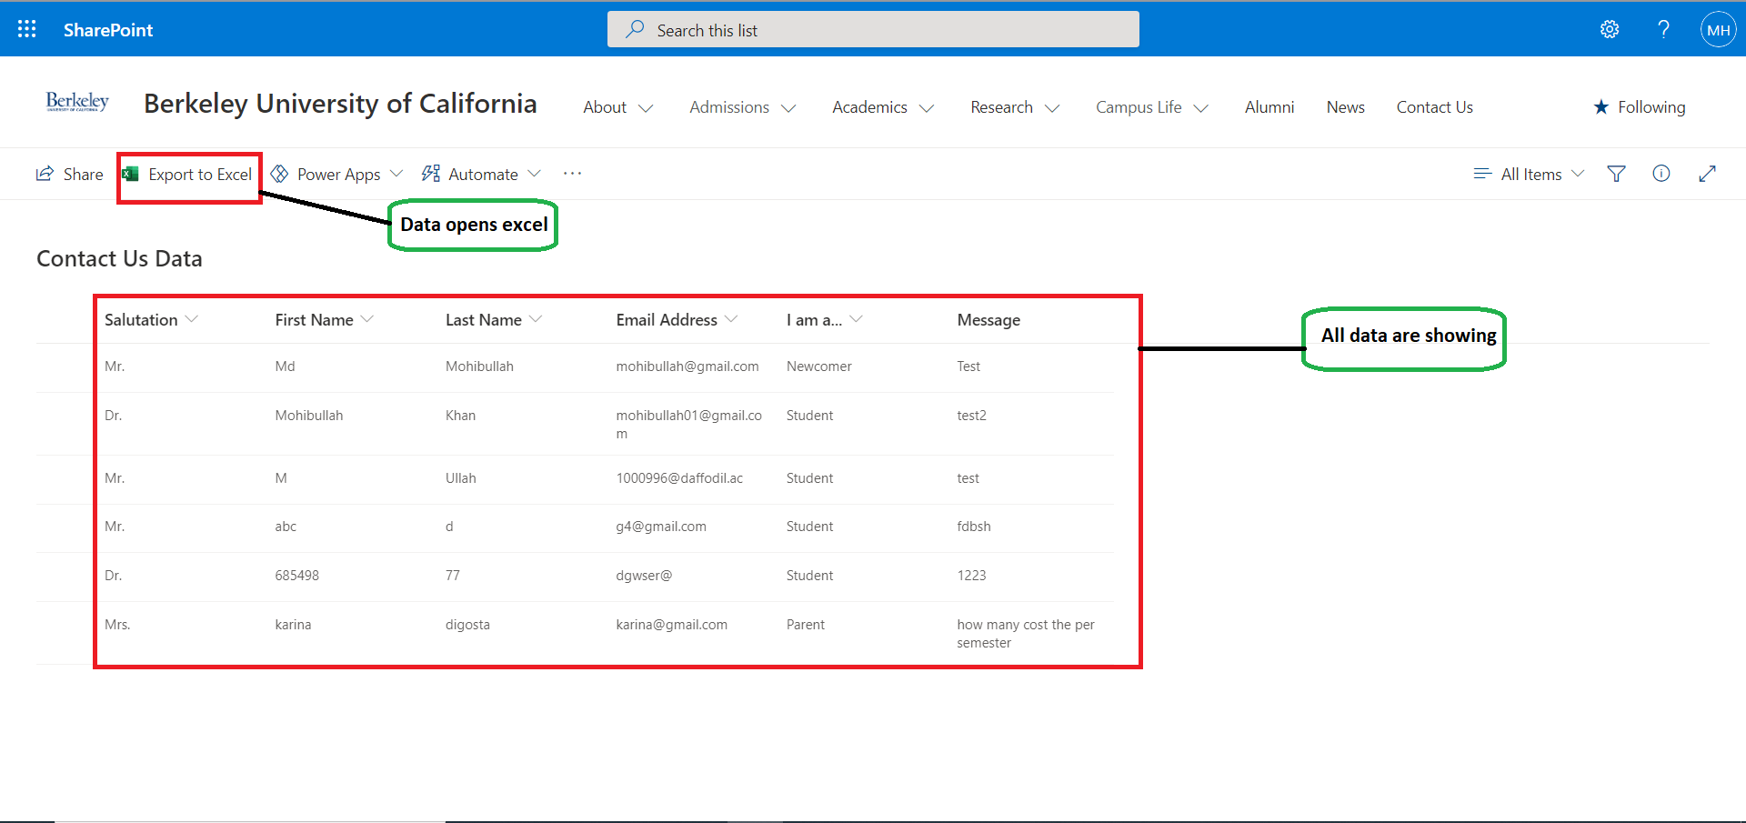

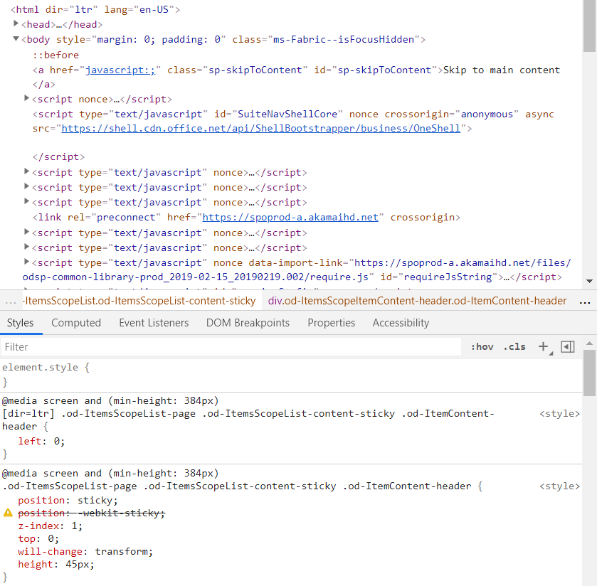

Figure: Security test for database.

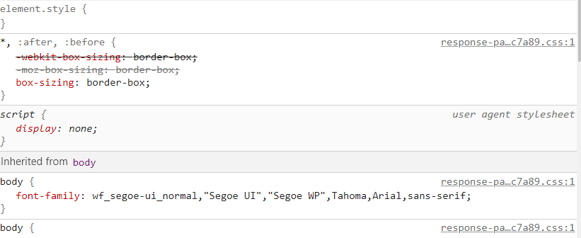

Figure: Security test for vulnerability.

**Responsiveness testing:**

Responsiveness defines how responsive the website is. It is an approach that makes web design render and adapt with variety of devices, screen sizes, whether it is a desktop, laptop, tablet or a mobile phone. It also means testing the website URL from different devices. There are different software tools to check the responsive percentage of a web application.

Here I have tested the developed website on following devices:

* Mobile
* Tab
* Notebook

|  |  |  |  |  |  |
| --- | --- | --- | --- | --- | --- |
| Test no. | Test title | Testing process | Expected result | Actual result | Action taken |
| 1 | Responsiveness testing (Mobile) | Visiting the website in a mobile. | The website will adapt with the mobile screen size. | The website is perfectly appeared in mobile phone. | None |
| 2 | Responsiveness testing (Tab) | Visiting the website in a tab. | The website will adapt with the tab screen size. | The website is perfectly appeared in tab. | None |
| 3 | Responsiveness testing (Notebook) | Visiting the website in a notebook. | The website will appeared perfectly in a notebook. |  | None |

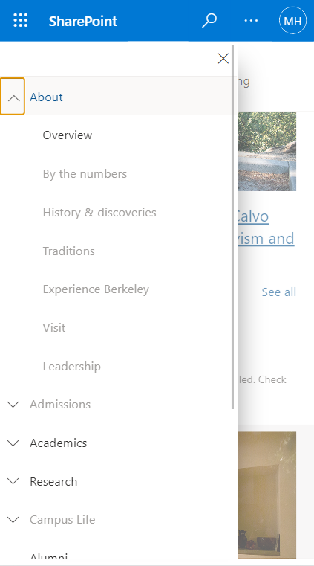

Figure: Mobile responsive testing.

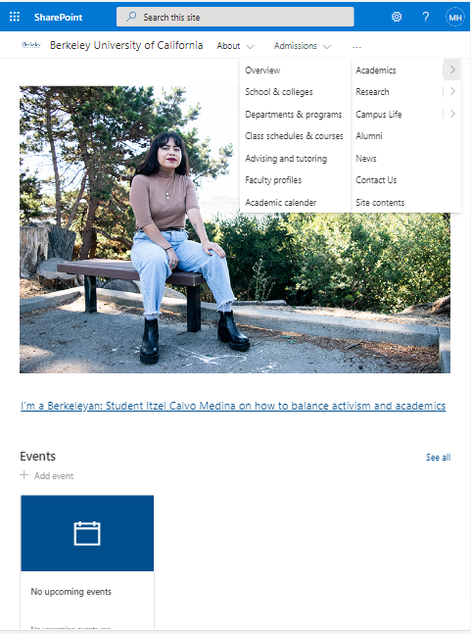

Figure: Tab responsive testing.

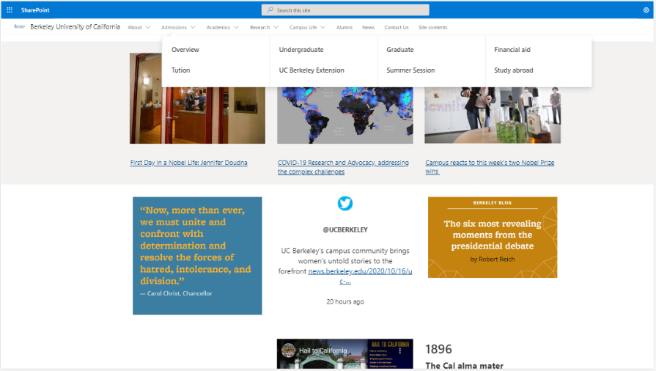

Figure: Notebook responsive testing.

**Browser compatibility testing:**

It means the website we have developed is working as expected in any browser. So the process to test the developed web application works as intended in any given browser is the Browser Compatibility Testing.

Here I have tested the developed website on following browsers:

* Google Chrome
* Mozilla Firefox
* Internet Explorer

|  |  |  |  |  |  |
| --- | --- | --- | --- | --- | --- |
| Test no. | Test title | Testing process | Expected result | Actual result | Action taken |
| 1 | Browser compatibility testing | Operating the website on Google Chrome. | The functions of the website will run successfully. | The website has run perfectly. | None |
| 2 | Browser compatibility testing | Operating the website on Mozilla Firefox. | The functions of the website will run successfully. | The website has run perfectly. | None |
| 3 | Browser compatibility testing | Operating the website on Internet Explorer. | The functions of the website will run successfully. | The website has run perfectly. | None |

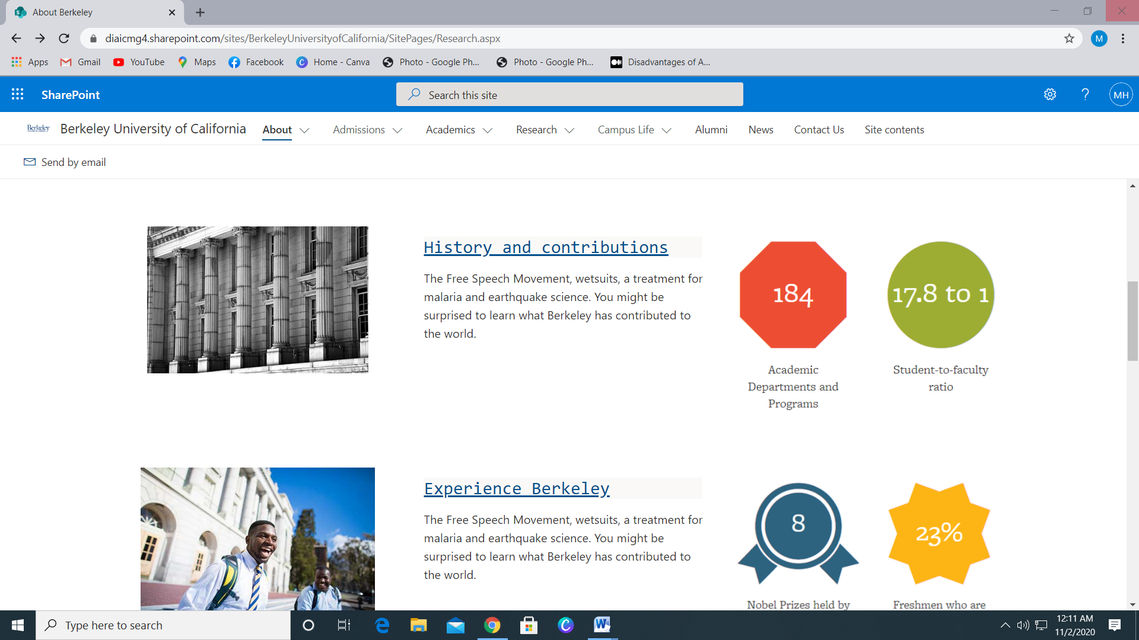

Figure: Google Chrome compatibility testing.

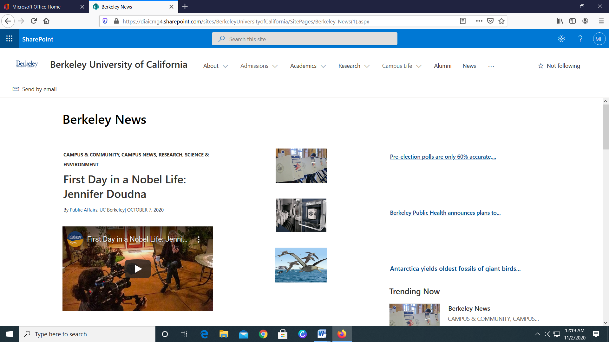

Figure: Mozilla Firefox compatibility testing.

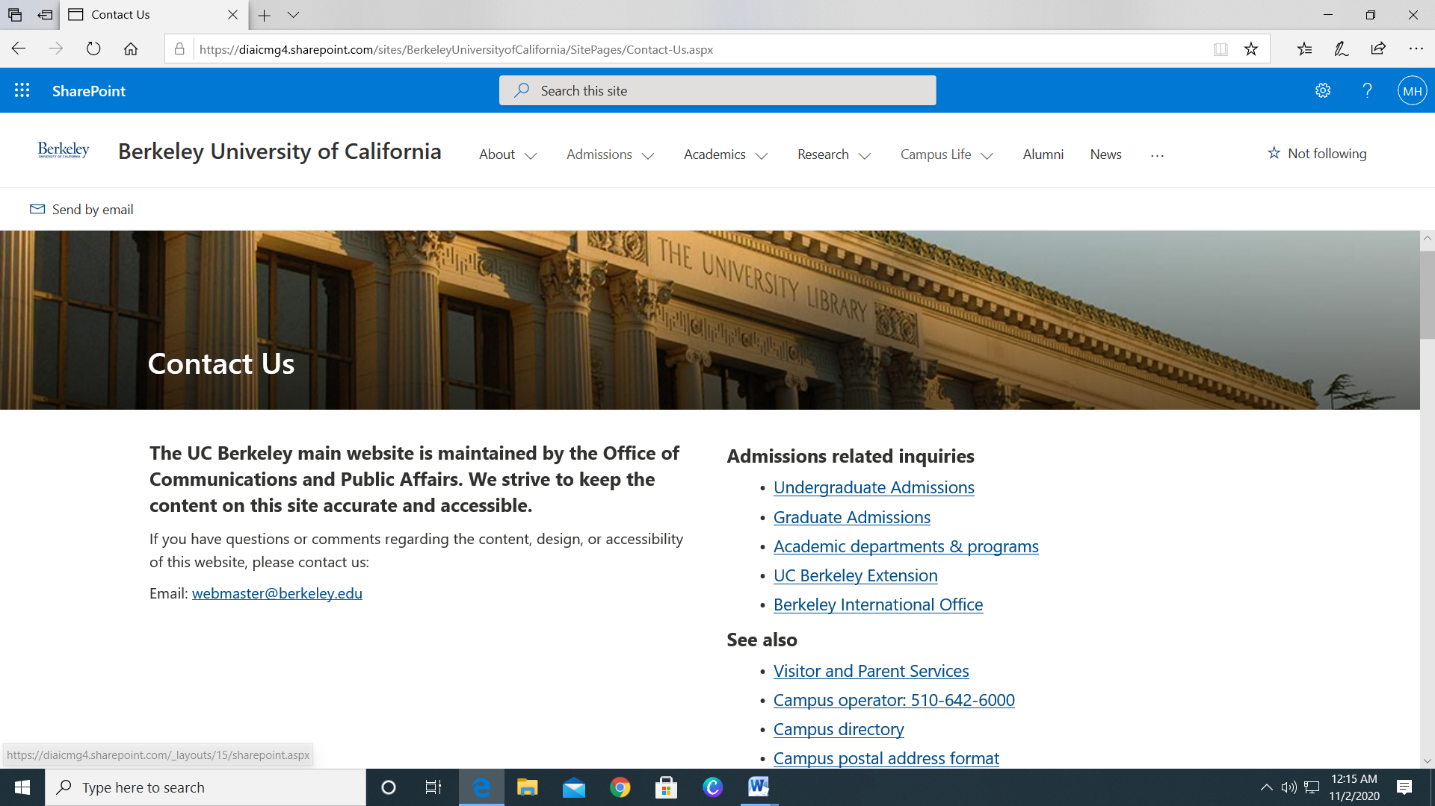

Figure: Internet Explorer compatibility testing.